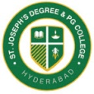
ST. JOSEPH’S DEGREE & PG COLLEGE
(Autonomous), Affiliated to Osmania University
Re-accredited by NAAC (3rd Cycle) with B⁺⁺ Grade
King Koti Road, Hyderabad

Department of Mathematics & Statistics
Report on Knowledge Sharing
Name of the Event : Knowledge Sharing
Date : 20th Nov 2021
Time : 1.40 PM to 3.30 PM
Venue : Govt. Boys High School Aliya, Gunfoundry, Hyderabad
Target Group : IX & X Standard students
Faculty Coordinators : Mrs. S. Vijayalaxmi & Mrs. J. Harika
Objective of the Activity:
The main objective of the activity is to share the knowledge of Basic concepts of Mathematics and Career guidance in higher studies to the IX & X Standard students of Govt. Boys High School Aliya, Gunfoundry, Hyderabad.
Report:
The Department of Mathematics & Statistics conducted “Knowledge Sharing” activity to the IX & X Standard students of Govt. Boys High School Aliya, Gunfoundry, Hyderabad. The students of B.Sc second year Mr Aditya Raj shared his knowledge on the Topic “Mensuration” by explained the formulae with real life applications and Ms. Cherishma shared her knowledge on the Topic “Trigonometry” and explained the real life applications.
The students of B.Sc final year Mr. Kevin from MSCs-IIIB delivered a motivational speech to the students and students enthusiastically shared their goals. Mr. Shiva Krishna from MECs-IIIA guided the students for higher education and the career opportunities. He also explained about how to reach their goals in future and most of the students were curious to know about the opportunities. Ms. Bijli Bigy from MSCs-IIIB guided the students on how to acquire better path in their future in reaching their goals.
The teachers of the school appreciated the initiatives taken by the department for guiding and motivating the students for their better future and also they appreciated our students for giving the valuable inputs and suggestions in reaching their bright future.

Photos with Caption
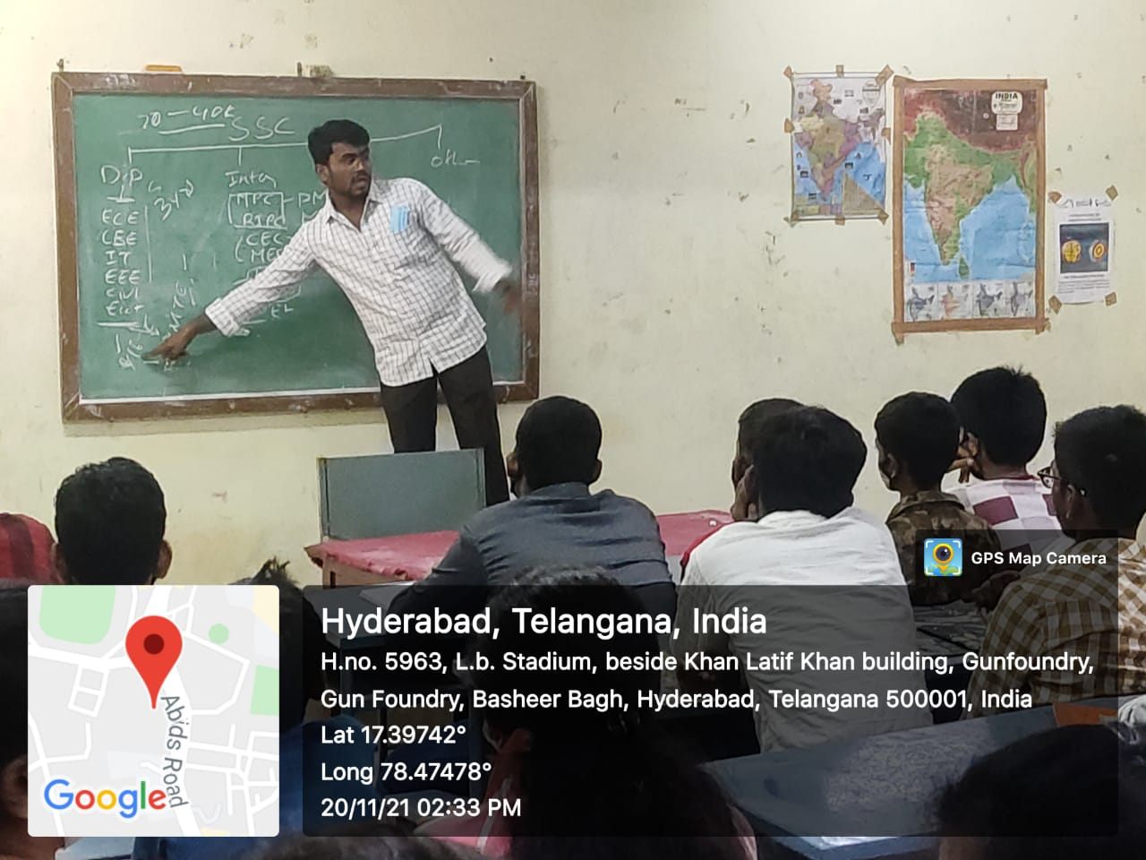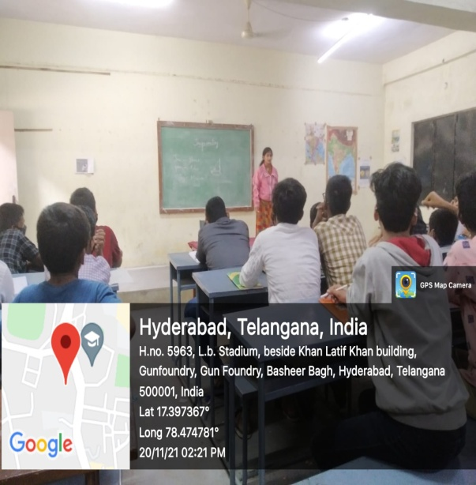

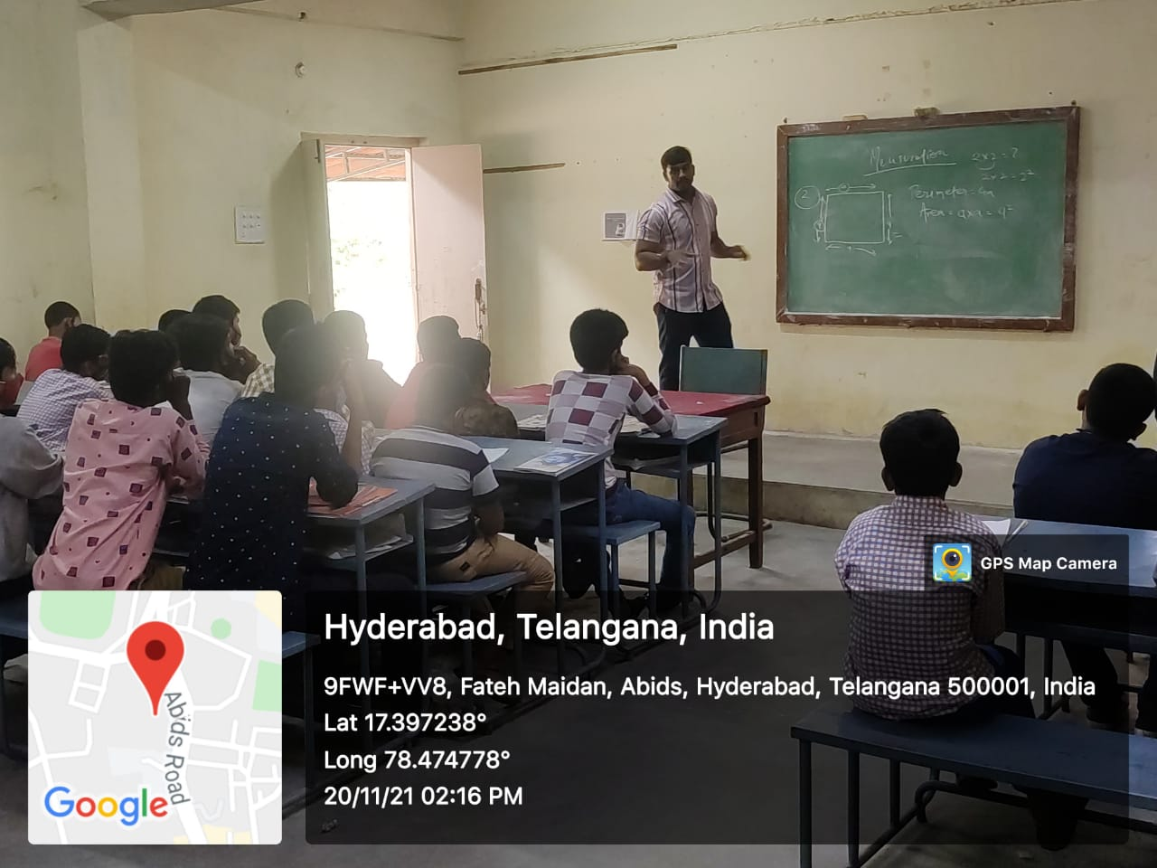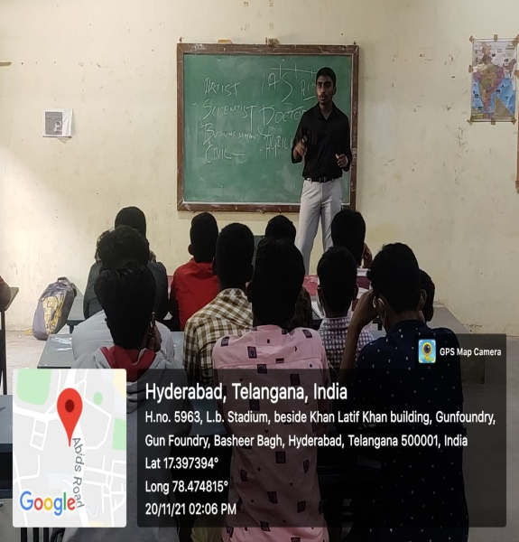
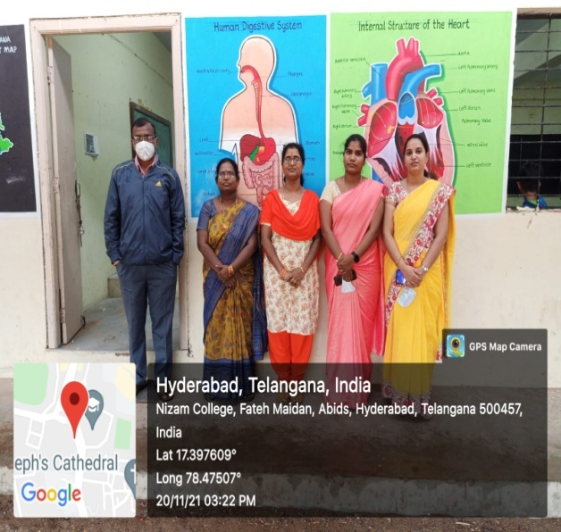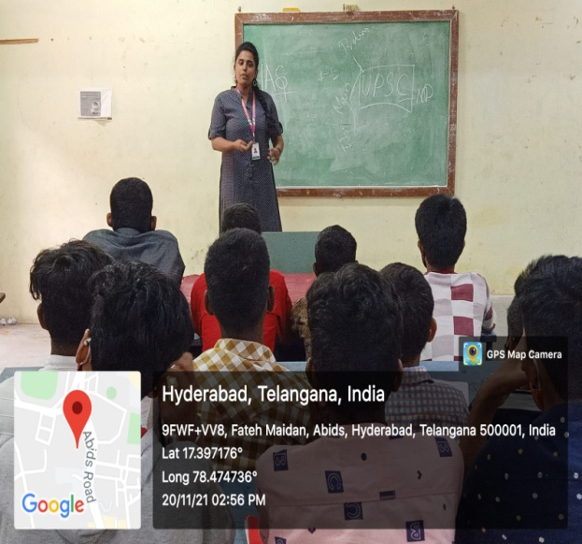

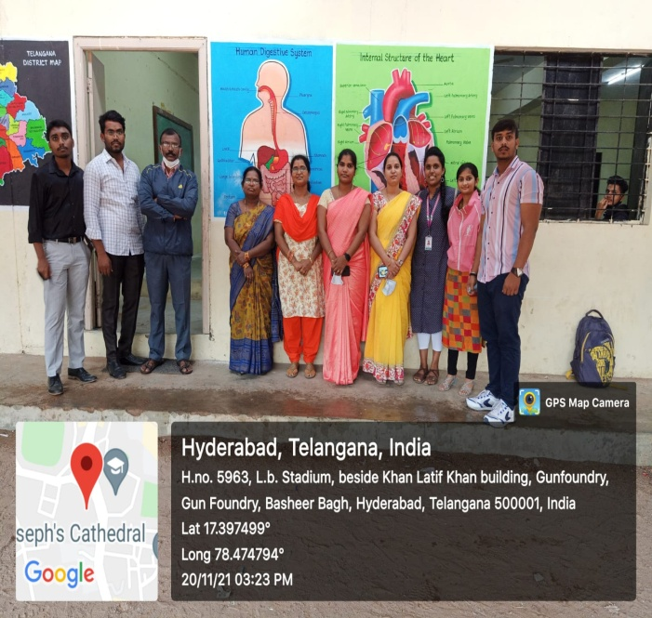
Outcome:
The students were interactive throughout the session and gained the knowledge on how to develop their career, opportunities provided by Government and private sectors in setting the future goals.

List of Students:
S.No | Roll No. | Name of the student | Class
1 | 121420467020 | V. Cherishma | B.Sc MSCs-II Year
2 | 121420467026 | Aditya Raj | B.Sc MSCs-III Year
3 | 121419467007 | Bijli bigy | B.Sc MSCs-IIIYear
4 | 121419467020 | Kevin Harry | B.Sc MSCs-IIIYear
5 | 121419474023 | Shiva Krishna | B.Sc MECs-III Year

