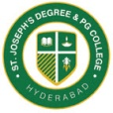
ST. JOSEPH’S DEGREE & PG COLLEGE
(Autonomous), Affiliated to Osmania University
Re-accredited by NAAC (3rd Cycle) with B⁺⁺ Grade
King Koti Road, Hyderabad

Report on Two Day Workshop

Name of the Event : Two Day Workshop on “Tableau & Power Bi”
Resource Person : P. Bhaskar Reddy, Data Scientist, TCS, Hyderabad
Date : 24th & 25th Mar 2022
Time : 11.30 AM onwards
Venue : 3rd floor lab
Target Group : B.Sc Second & Final year
Faculty Coordinator : Mrs. S. Vijayalaxmi
The Department of Mathematics & Statistics conducted a two Day Workshop on “Tableau & Power Bi” software’s for B.Sc final year and selected students of second year on 24th & 25th March 2022 from 11.30 AM onwards in 3rd Floor lab-1.
The resource person for the workshop was Mr. P. Bhaskar Reddy, Data Scientist, TCS, Hyderabad.
Day 1:
The workshop started with an introduction of Power Bi software by using data visualizations and Analytical tools for Business Intelligence. He also presented the over view of the software in detail about sources of Get data and to analyze the data using more than 150 powerful visualizations, how to publish the reports publically and collaborations in the software. The analysis of the data was demonstrated from the web using Population survey in the year 2011 as an example.
Day 2:
The session 2 started with the introduction of various tools like colors, labels, axis etc using filters. He also imparted the knowledge of analysis using real time project and explained about various tools and visuals in the software. The students were very enthusiastic in learning the software with real life applications and they were interactive throughout the session.
The session was ended by presenting a memento as a token of appreciation and followed by a formal vote of thanks.

Photo Gallery:
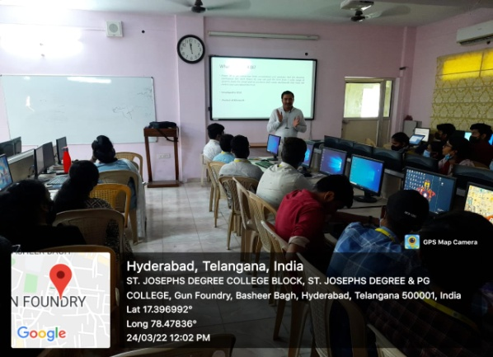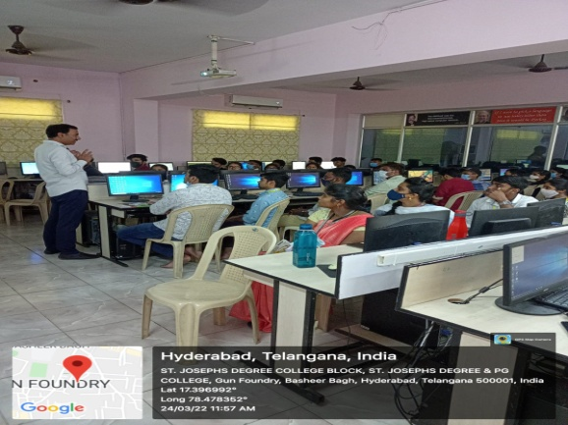

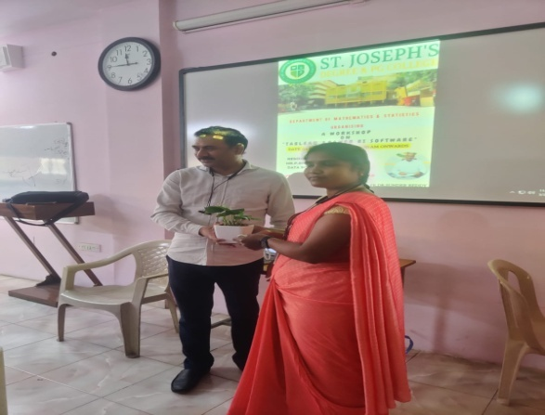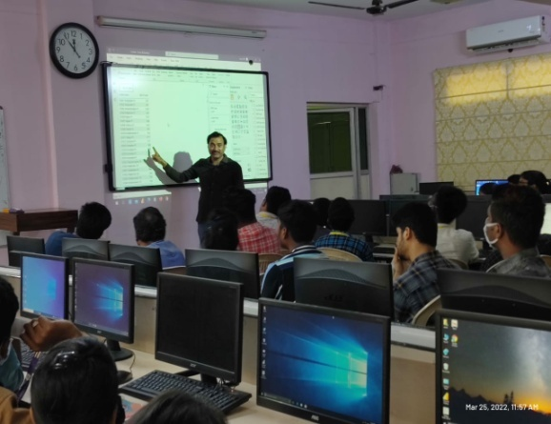

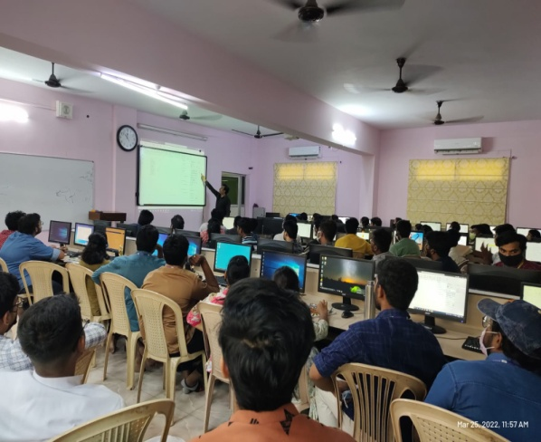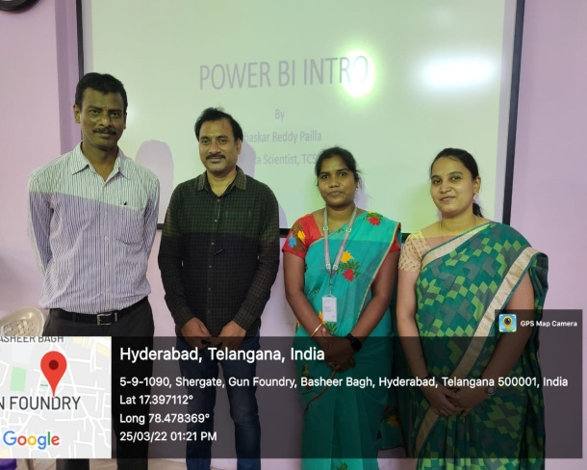

List of Students:
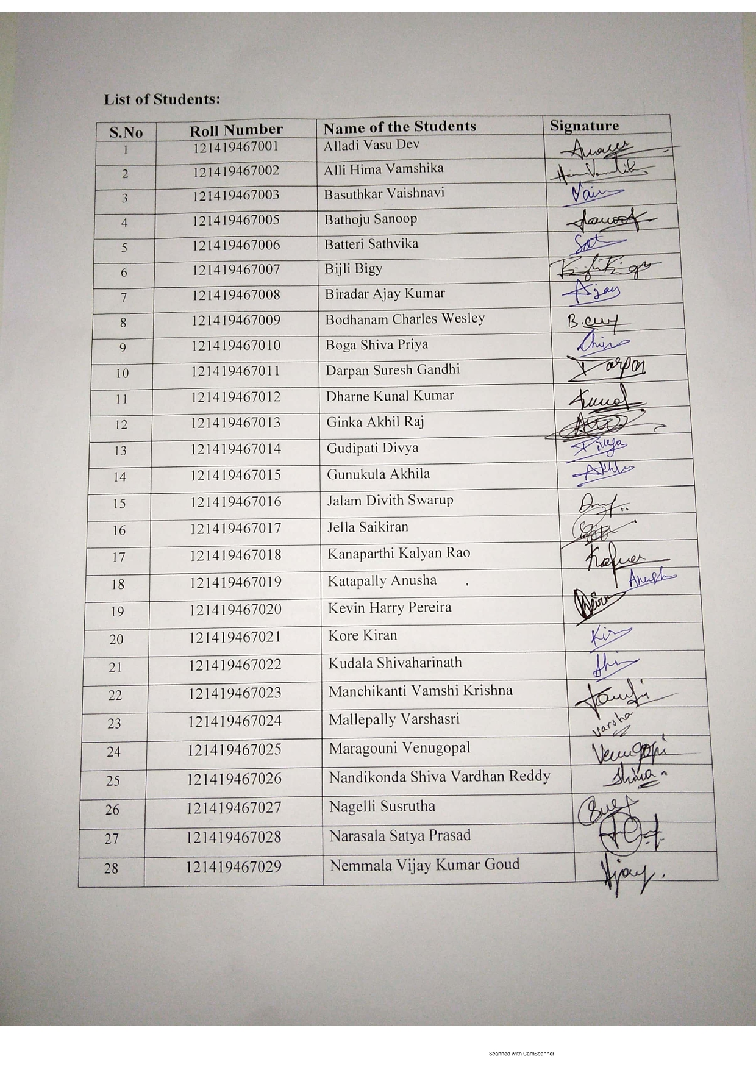
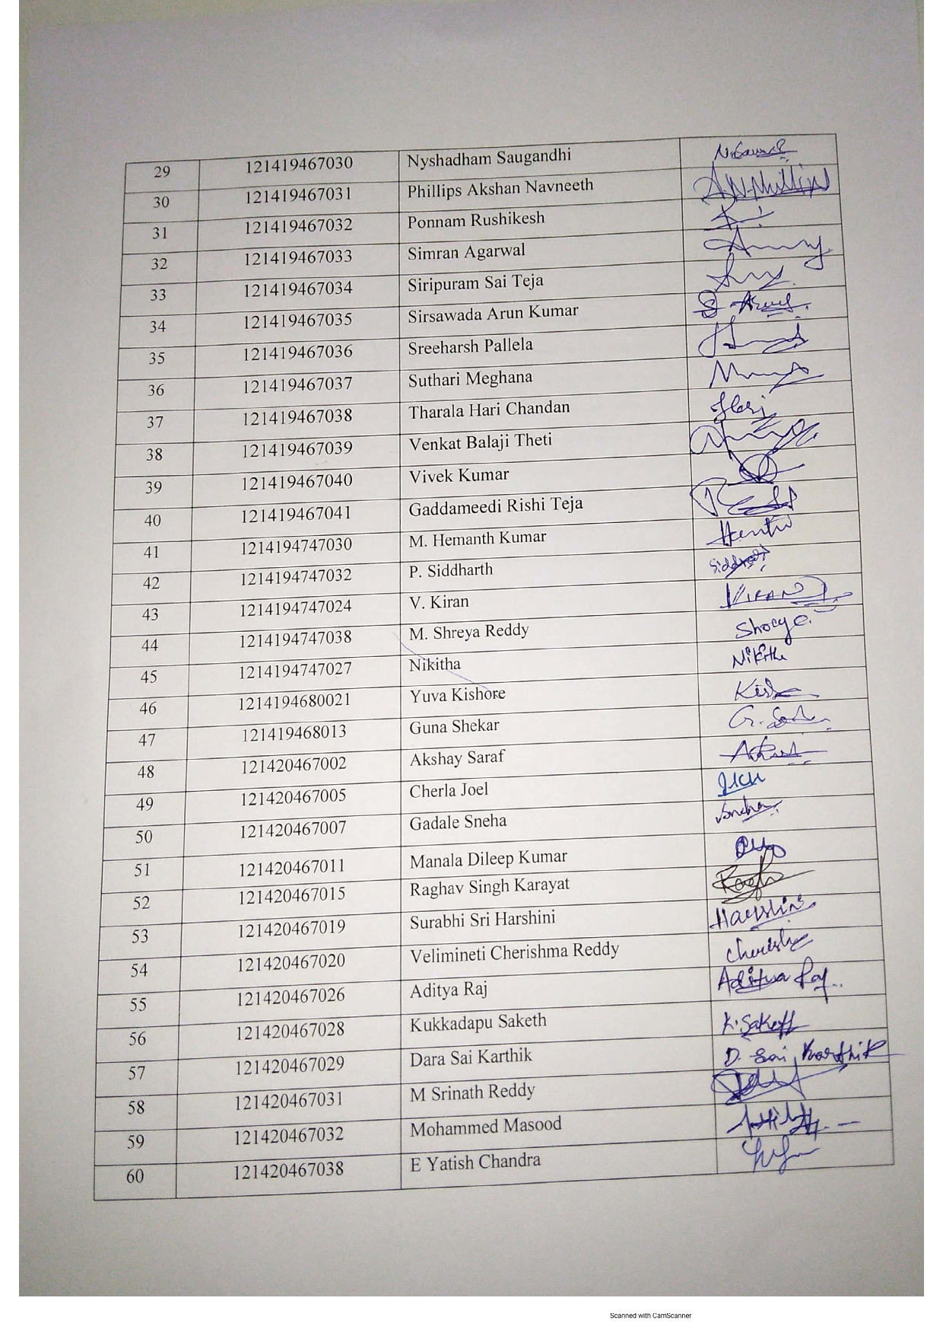
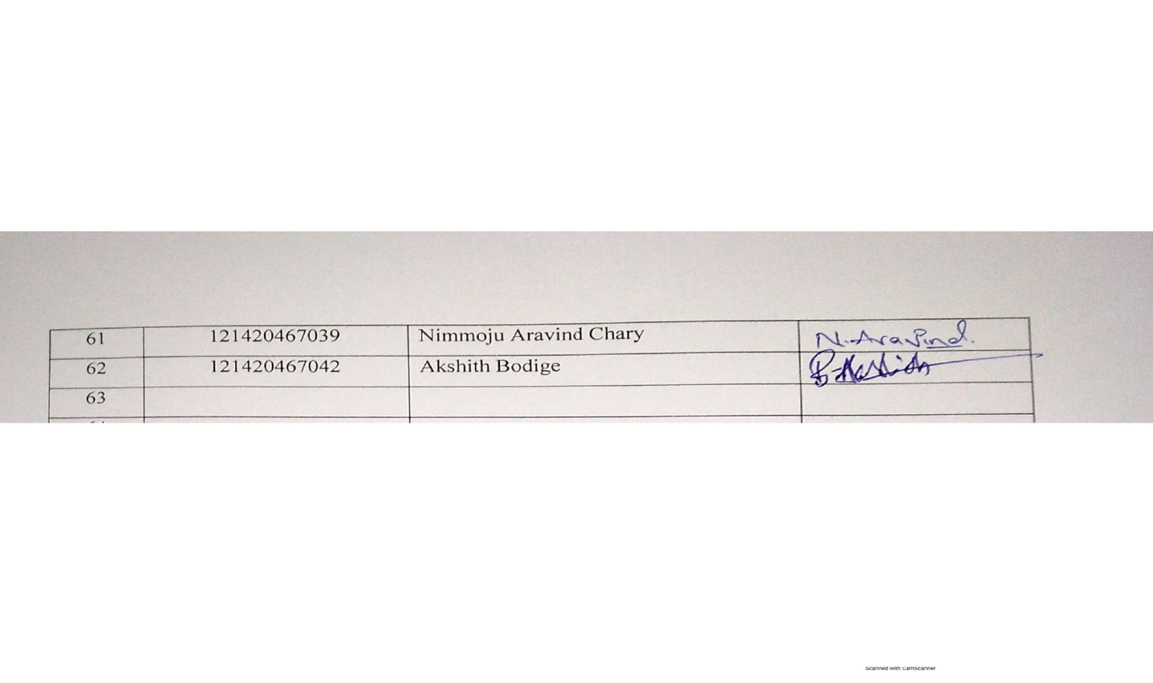
Feedback on Resource Person and session:

- Communication & presentation skills of the resource person

- Rate the resource person
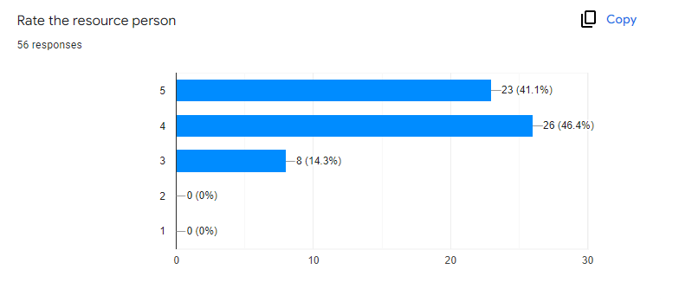
- Was the session informative?

- Major take away from the students are:

- The workshop was very informative and clear, we got a clear understanding of the software’s tableau and power bi.
- Learnt a new and quick way of using Tableau and Power Bi
- He gave information regarding technology data analysis software which useful in the current scenario
- We have good input of different software which help us build our career
- How the tools are used in the industry and an insure about the Industry
- Learnt something new and trendy which is going to help us in future
- Learnt about tableau and how animations can be performed using it.
- I learned New Things and Real life Applications through this Software’s
- The session was really informative. It helped me to gain knowledge on Power Bi
- The session was good .I got to know about many things.
- Please rate your overall experience of the workshop

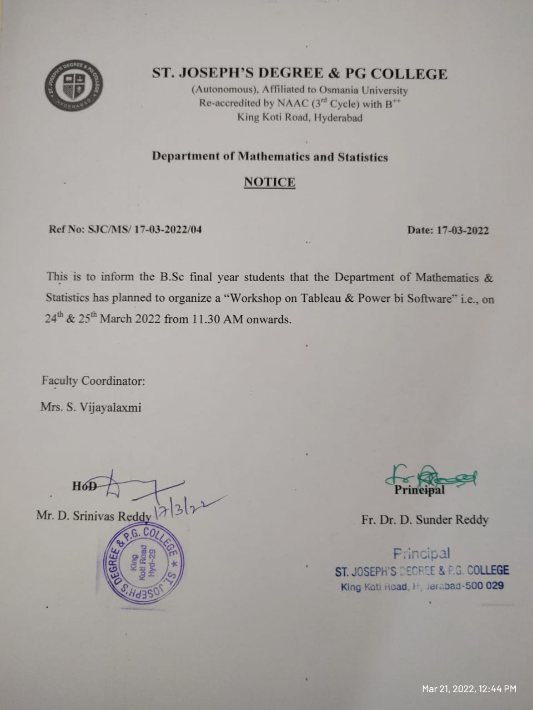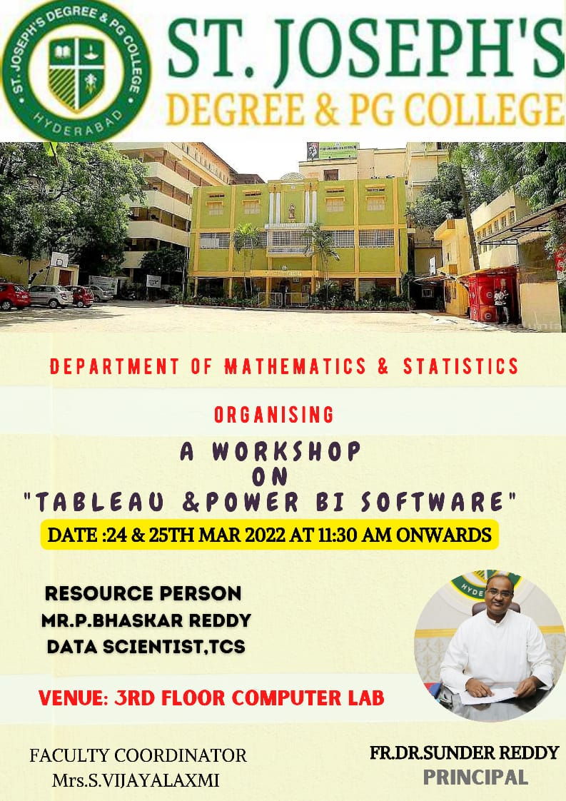

Principal
Fr. Dr. D. Sunder Reddy

