Department of English

Faculty Profile |  | 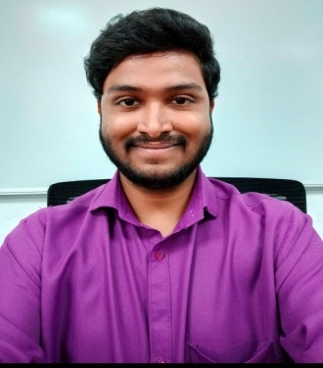
Personal Details
Name | G. PRAVEEN KUMAR
Designation | ASSISTANT PROFESSOR
Qualification | B.A (EPP) M.A (ENGLISH AND LITERATURE) PGDTE-ENGLISH  Completed Personality Development course from CELT (CentreforEnglishLanguage  Training) Osmania University on 27th September 2019.
Mail-Id | gpraveenkumar@josephscollege.ac.in
Mobile Number | 8977579428
Academic Details
Academic Qualification | B.A (EPP) M.A (ENGLISH AND LITERATURE) PGDTE-ENGLISH
Work Experience Details
Work Experience | - Appointed on January 1st 2022, Currently working as an Asssistant Professor of English in St. Josephs Degree and P.G College- Hyderabad KingKoti.  - Worked as an Assistant Professor of English in Avinash college of commerce –Hyderabad, from 20-6-2018 to june 2021  - Worked as an English lecturer at srisai vidya vikas junior and degree college from june-2017 to 2018
Paper Publication Details
Paper Publications | Paper Details
- Participated and presented paper in one day National seminar entitled “Need for Incorporation of communicative English in curriculum held on 10-1-2020 at AV Kantamma college for women, Hassan Karnataka.

- Presented a paper entitled Effect of lock down on Educational sector in the
- International conference on “Global Economic Impact of COVID-19”(ICGEIC-2020)on
- 9th and 10th June 2020.

- Presented a paper entitled “FABRICATING LEADERSHIP WITH EMOTIONAL INTELLIGENCE ININDUSTRY 4.0”in the Two Day International Virtual Conference on INTER DISCIPLINARY RESEARCH INNOVATIONS IN SCIENCE AND HUMANITIES (IC–
- IRISH'20) on 29th and 30th of November 2020.

Workshops/Seminars/FDP/Referesher Courses/MRP
- Participated in faculty development programme on “Leadership building and Professionalism at work place”organized by Faculty professional development Cell ,St.Francis College for Women, Hyderabad on 19TH July 2019.

- Attended a faculty development programme on “Research Methodology” held at IIMC on August7th 2019.
- Attended one day State level work shop on “Teaching skills and strategies on English language classroom” conducted by Indian institute of management and commerce,Hyderabad on 28-2-2019

- Enrolled and took part inTwo-day faculty development programme on “Improving
language skills for effective communication”on 20th and 21stof November 2019
organized by TASK (Telangana academy for skill and knowledge)

- Participated in “Faculty developmentnal Success” organized by Department of Commerce on 18-December-2020
from Little flower degree college Uppal,Hyderabad.
- Participated in theNational webinar on"Content Writing and Copy writing: Using
Language and Creativity to Create an Impact"organized by the Department of
Communicative English, Asutosh College in association with IQAC, Asutosh College on August 18,2020.

- Participated in the faculty development programme in Aurora Degree and P.G college
- on ‘Reading literature for language enrichment’ held on 27th may 2021.

- Attented a National level five day virtual workshop on Research paper writing in English Literature and ELT Organized by the department of English in association with the IQAC Jain College from 17th January to 21st January 2022.

- Participated in the 7 days FDP on Exploring Dynamics of the Classroom-NEP and NAAC perspective organized by IQAC of St. Pauls College, Bengaluru from 20 January to 28 January 2022

- Participated in the online FDP on Student centric methods and its documentation organised by the Department of Commerce and IQAC , St. Joseph Degree and PG College on 19th April 2022.

Achievements Details
Awards & Rewards | - Presented papers for National and International Conferences.  - Was a panel member in designing material for soft skills, basic level.
External Paper Setting details
External paper

