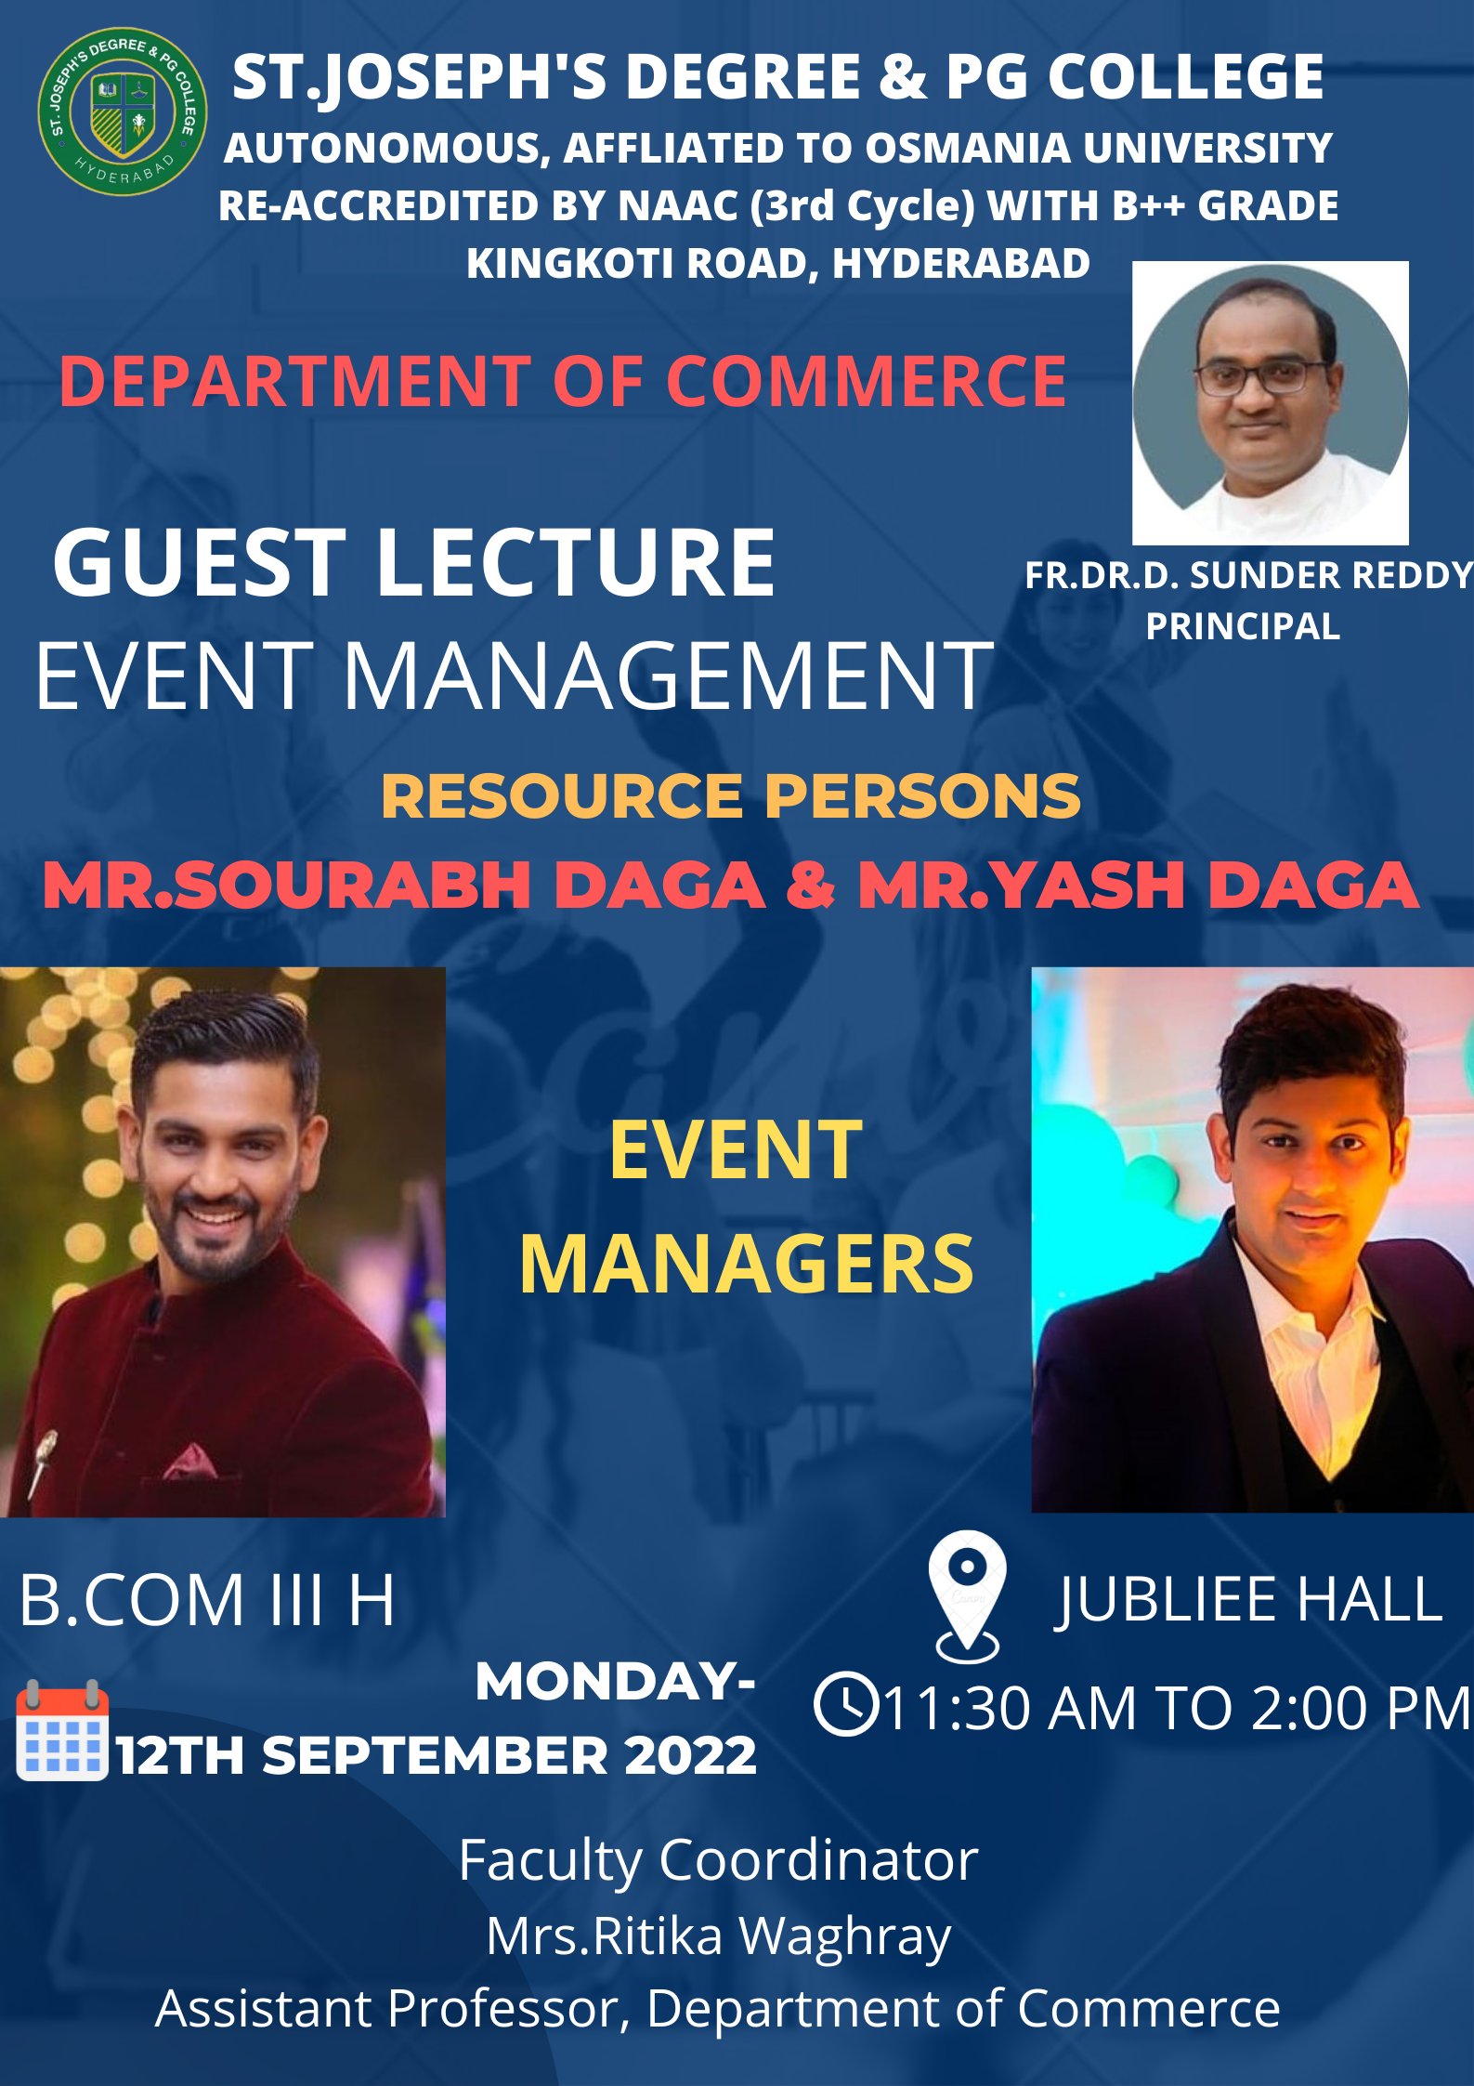

NAME OF THE EVENT: Guest Lecture on Event Management
OBJECTIVE OF THE EVENT: To give key practical insights on Event Management and to get a closer view of the Event industry.
OUTCOME OF THE EVENT: It was a fun and interactive session where the Daga Brother’s interacted with the students and also encouraged them to pursue their career in event managing.
LIST OF PARTICIPANTS:
S.No | Roll NO | Name of the Student
 | 121420407001 | ADITI BANSAL
 | 121420407003 | AINALA THARUN REDDY
 | 121420407004 | AKEPOGU SAMUEL AKASH
 | 121420407005 | ARINDOM DAS
 | 121420407008 | AYUSH VERMA
 | 121420407009 | AYUSHI AGARWAL
 | 121420407010 | AYUSHI KEDIA
 | 121420407012 | BHAVIK AGARWAL
 | 121420407014 | CHITTALA APURUP ABRAHAM
 | 121420407015 | DEEPAK SHARMA
 | 121420407016 | ESHITA EVITA PETER
 | 121420407017 | GAURI SHINDE
 | 121420407018 | GIRISH BARARIA
 | 121420407019 | GODA RAMYA YADAV
 | 121420407021 | DEORA SWAROOP KUNWAR
 | 121420407022 | HARSH RAI
 | 121420407023 | HARSH SHARMA
 | 121420407024 | KHUSHI KACHWAHA
 | 121420407025 | LEENA LUNIA
 | 121420407026 | M VIVEK GOUD
 | 121420407027 | SHATAGOPAM VISHWAK
 | 121420407028 | MANSHA AGARWAL
 | 121420407029 | NAMAN KUMAR BALAR
 | 121420407030 | PAYAL PIPRIYA
 | 121420407031 | POTEL TANISHQ YADAV
 | 121420407033 | PRATHIK BAJI
 | 121420407034 | PRERANA KHANDELWAL
 | 121420407035 | RAKSHA JAIN
 | 121420407036 | CHALLA RAMYA
 | 121420407037 | RISHIKA TAK
 | 121420407038 | RISHIUPADHAYA
 | 121420407043 | SOWMYA YADAV
 | 121420407044 | SANYAM SETHIA
 | 121420407045 | SUJAL UPADHYAY
 | 121420407047 | THAKUR RISHIKA SINGH
 | 121420407048 | UNNATHI AGARWAL
 | 121420407049 | UPADHYAY HEERAL
 | 121420407052 | VISHAKA INANI
 | 121420407053 | VIVEK MODANI
 | 121420407054 | YEDUGANI SHRUTHI
 | 121420407055 | YOGEETA THAKUR
 | 121420407056 | T SHIRISHA DEVI
 | 121420407058 | JUREDDY TEJA SWAROOP
 | 121420407060 | RISHIKA PODAR

DATE, TIME, & VENUE: 12th September, 2022, 11:30 AM to 2:00 PM, Jubilee Hall
NO. OF PARTICIPANTS: 44
FACULTY CO-ORDINATOR:
Mrs. Ritika Waghray, Assistant Professor, Department of Commerce
TARGET AUDIENCE: B. Com III H
NAME AND DESIGNATION OF RESOURCE PERSONS:
Mr. Sourabh Daga | Event Manager
Mr. Yash Daga | Event Manager

A BRIEF REPORT:
The guest lecture was given by Daga Brothers in Jubilee Hall from 11:30 am onwards. The guests were introduced by Harsh Rai, and then they had started with their session.

They explained that how “every event is a life event.” Next, they talked about the importance of money. They have also made a point that initially the event managers have to organize the events for free so that we can get maximum experience and promotion for our event brand. They spoke about various checklist for an event. Topics like Location, Creativity, Logistics, Target, Finance, Marketing, Scheduling, Security were discussed. An important concept of Margin of safety in Event Management was explained. They also spoke about the budgeting and financing techniques to be used while going for an event. They shared few tips on quoting the budgets to clients and how one can make profit even if the budget is small. Then they spoke briefly on Wedding management, corporate event and Retail marketing. They also spoke on the necessity to have a backup plan for any event. However, they said it may not always be possible to have one, and we can take alternative approaches from client in this regard.
A practical approach session was organised by the Daga Brothers where students were given two scenarios with a budget of 10 lakhs. and they had to form groups and pitch an event plan to the client
- Plan a college event and organize Singing and dancing competition for 15 colleges.
- Plan any 1 wedding gig in a Banquet Hall for 800 members
The session ended by a vote of thanks by Avantika Pandey.
Feed Back Analysis: The students appreciated the Guest Faculty. They were very happy the way each aspect was covered and specially the practical approach. They found it very helpful and learnt a lot of new things. It was Very interesting and encouraging. They also said that they Got exposure to a bit of the event management world as how events can be organized smoothly.

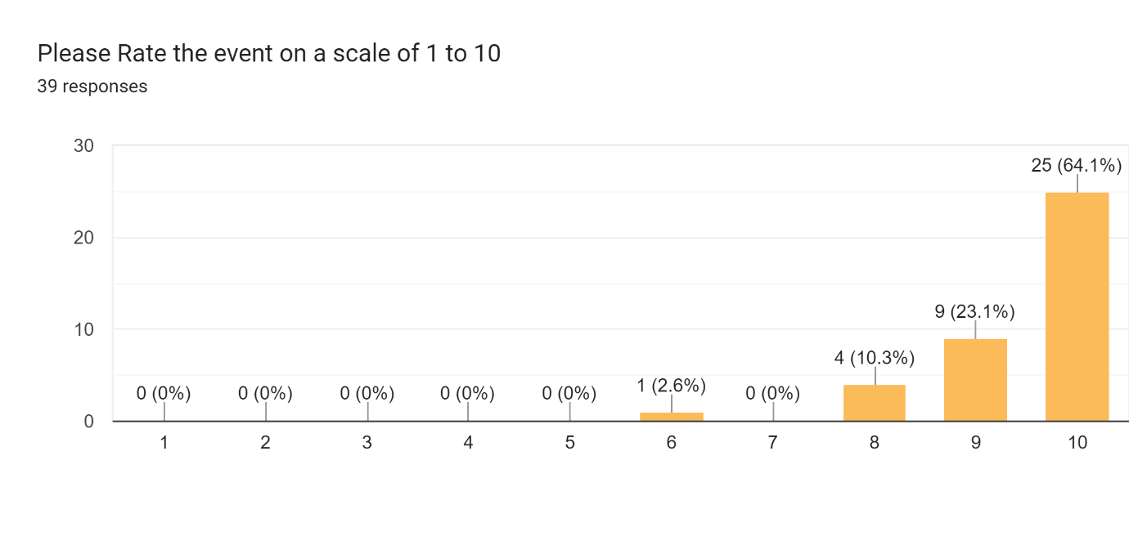
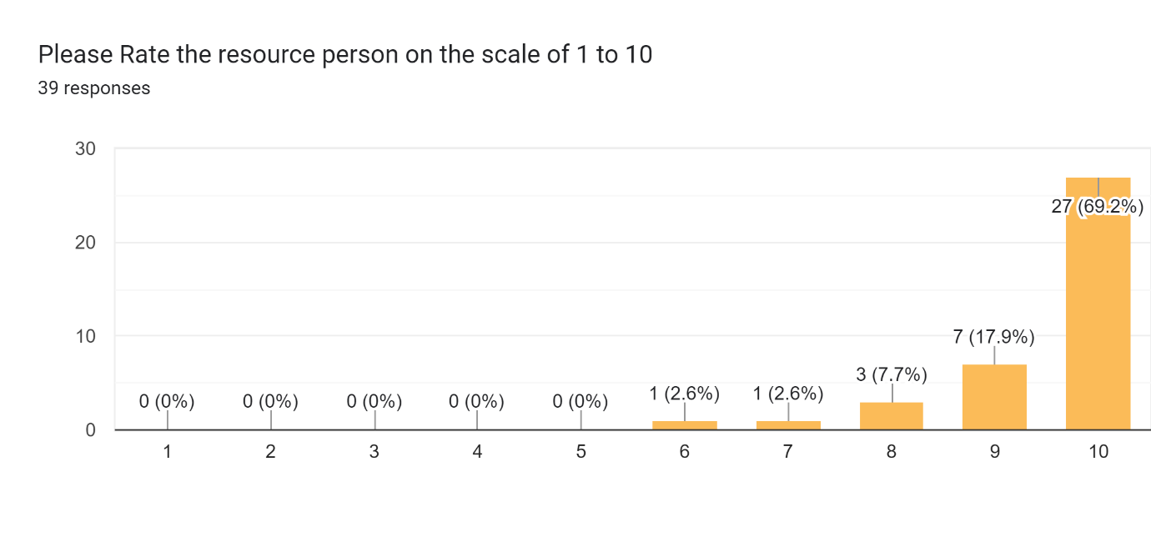

PHOTOGRAPHS:
