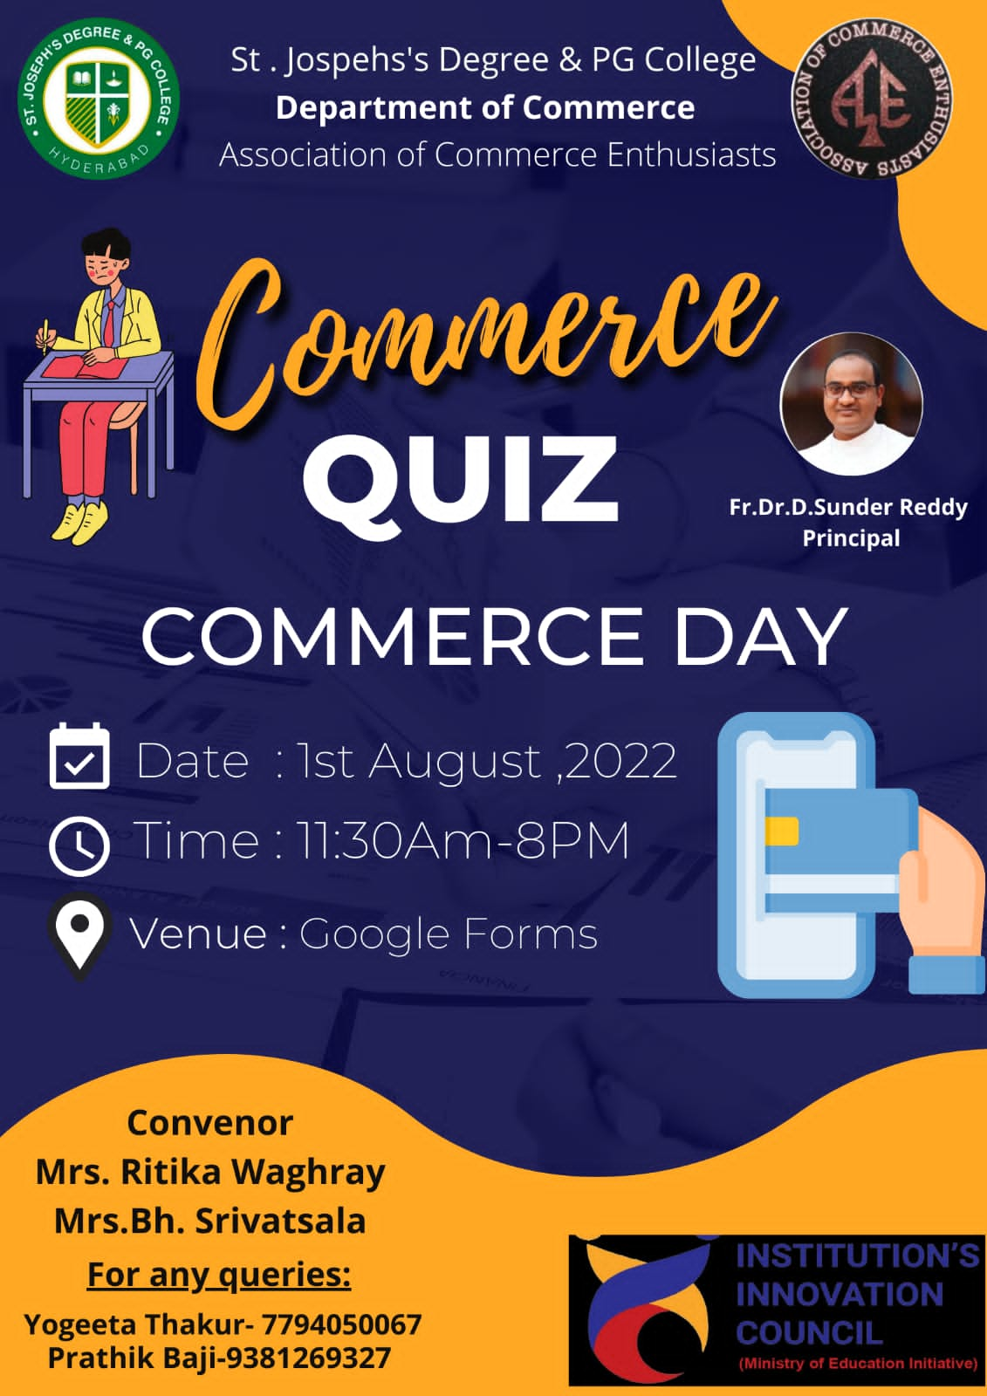
NAME OF THE EVENT: ONLJNE COMMERCE QUIZ
OBJECTIVE OF THE EVENT: The Objective behind to organize Quiz competition is to evaluate the knowledge of the participants within academics as well as beyond academics and to make them familiar with the prospects of quizzes and the objectivity of the questions.
OUTCOME OF THE EVENT: Quizzes encourage student’s self-awareness of progress and self-assessment. By taking quizzes, they are able to get an instant feedback on their responses. This helps them to identify areas they need to develop themselves.
NOTICE REFERENCE#:
LIST OF PARTICIPANTS:
Registration no. | Name | Class | Roll No.
ACE/OCQ/22/001 | Tasleem Abuwani | BCom 2 Honors | 121421407054
ACE/OCQ/22/002 | Mohd Mateen Rahil | B com computers 3D | 121420402090
ACE/OCQ/22/003 | Girish Bararia | Bcom 3 honors | 121420407018
ACE/OCQ/22/004 | Avantika Pandey | Bcom 3 honors | 121420407007
ACE/OCQ/22/005 | Fatima ruhi | Bcom 2 honors | 121421407012
ACE/OCQ/22/006 | Ayushi agarwal | Bcom 3 honors | 121420407009
ACE/OCQ/22/007 | Mir Adnan Ali | Bcom 2 Computers | 121421402030
ACE/OCQ/22/008 | Veda Vyas | BA MCJ 2 | 121421400007
ACE/OCQ/22/009 | Mohammed Razaullah | B.com 2 computers | 121421402096
ACE/OCQ/22/010 | Sputhnika Reddy | Bcom computers IIC | 121421402049
ACE/OCQ/22/011 | G MEGHNA REDDY | BCom 2 IT | 121421405028
ACE/OCQ/22/012 | Manas Mandal | B.com Computers | 121421402083
ACE/OCQ/22/013 | Lohitha Reddy Gangalapudi | B Com 3 IF&A | 121420409035
ACE/OCQ/22/014 | J.Akshitha Yadav | B.com 2 IFA | 121421409013
ACE/OCQ/22/015 | Vamshi krishna alladurgam | Bcom-IT 2 | 121421405002
ACE/OCQ/22/016 | G. Trisha | BCom IT | 121421405004
ACE/OCQ/22/017 | K B Deepika | Bcom IFA 2 | 121421409016
ACE/OCQ/22/018 | N.Nisha | BCom 3 IT | 121420405028
ACE/OCQ/22/019 | Lavisha G. Parwani | BCom 3 IT | 121420405022
ACE/OCQ/22/020 | Gaddam kaushik siddharth | BCom 2 Computers | 121421402015
ACE/OCQ/22/021 | Sourabh | Bcom comp 2c | 121421402041
ACE/OCQ/22/022 | B. Preksha | B Com 2 Honors | 121421407007
ACE/OCQ/22/023 | Chityala Anantha Reddy | B.com 2c computers | 121421402010
ACE/OCQ/22/024 | Zaher Ahmed | BCom 2 IT | 121421405033
ACE/OCQ/22/025 | Katakam Anurag Reddy | BCom 2 IT | 121421405009
ACE/OCQ/22/026 | Rahul | BBA 2 entrepreneurship | 121421412049
ACE/OCQ/22/027 | Hima chandrika | B.Com 2 IFA | 121421409042
ACE/OCQ/22/028 | M.Tejasree | Bcom 2IT | 121421405010
ACE/OCQ/22/029 | Mohammed Adnan | BCom 2 IT | 121421405014
ACE/OCQ/22/030 | Samay dagia | Bcom computers 2D | 121421402103
ACE/OCQ/22/031 | Kuneeka Sukdeve | B.com 2 professionals | 121421403006
ACE/OCQ/22/032 | Thakur Rishika Singh | Bcom 3 Honors | 121420407047
ACE/OCQ/22/033 | Sowmya yadav | 3H | 121420407043
ACE/OCQ/22/034 | Kodukula Nirupama | BA MCJ 2 | 121421400035
ACE/OCQ/22/035 | Shristi Yadav | BA MCJ 2 | 121421400013
ACE/OCQ/22/036 | N. Vasu Sri | Bcom 2 computers | 121421402097
ACE/OCQ/22/037 | Mohsin khan | Bcom 2 honors | 121421407024
ACE/OCQ/22/038 | Heeral upadhyay | Bcom 3honors | 121420407049
ACE/OCQ/22/039 | Amina Ahmed | BCom 2IT | 121421405035

DATE, TIME & VENUE: 1stAugust, 11:30AM-8PM, Google Forms
LIST OF PARTICIPANTS: 39
LIST OF FACULTY CO-ORDINATOR:
Mrs Ritika Waghray | Convenor
Mrs Bh. Srivatsala | Convenor
Ms N. Sai Lakshmi | Faculty Co-ordinator
Mrs Namarta Rathi | Faculty Co-ordinator
Ms Simran Jain | Faculty Co-ordinator

LIST OF STUDENT CO-ORDINATOR:
S.NO | NAME | DESIGNATION | CLASS
1 | Yogeeta Thakur | President | B.com III-H
2 | Prathik Baji | Vice president | B.com III-H
3 | Pratham Kumar Jain | Secretary | B.com II-D
4 | Ali Zaidi | Event Manager | B.com III-A
5 | Roohi Yasmeen | Deputy Event Manager | B.com III-H
6 | Ramya Challa | Asst. Event Manager | B.com III-H
7 | Vanshika Marda | Public Relations Manager | B.com III-IFA
8 | Sanyam Sethia | Deputy Public Relations Manager | B.com III-H
9 | Md. Hussain | Asst. Public Relations Manager | B.com II-IT
10 | G.Thandava Krishna | Reporting Manager | B.com III-IT
11 | Aditi Bansal | Deputy Reporting Manager | B.com III-H
12 | Masarrath Azam | Asst. Reporting Manager | B.com II-IT
13 | Adnan wajid Hazari | Media Manager | B.com III-IFA
14 | Riya Purkait | Deputy Media Manager | B.com III-H
15 | Anil Chouhan | Deputy Media Manager | B.com III-D
16 | Vaishnavi M | Asst. Media Manager | B.com II-P
17 | Ayushi Kedia | Creative Manager | B.com III-H
18 | S.Sushanth Rao | Deputy Creative Manager | B.com III-IT
19 | Aditya Sharma | Student Co-ordinator | B.com III-H
20 | Jacob Augustine | Student Co-ordinator | B.com III-C

TARGET AUDIENCE: College Student
NAME AND DESIGNATION OF THE RESOURCE PERSONS: NA
NAME AND DESIGNATION OF THE JUDGES: NA
A BREIF REPORT:
On the occasion of Commerce Day which is every first Monday of August. This year, it falls on August 1. This is mainly celebrated in ICELAND. Commerce Day is a day to celebrate workers' daily services and sacrifices.
On the account of Commerce Day, ACE, Department of Commerce conducted a commerce quiz.The quiz consisted of 30 questions related to Commerce and recent changes in the industry. All the students of the Commerce Department, were informed about the quiz a day prior to the competition. A poster was shared among all the class groups, which gave detailed information about the event. The form was open for submissions at from 11:30am till 8pm.By the time the form was about to close we could find 39 entries. On an average, students scored 25 out 30 points. Four students scored 28/30.
Results
Score | Name | Class
28 / 30 | Mohd Mateen Rahil | Bcom Computers 3D
28 / 30 | Fatima ruhi | Bcom 2 Honors
28 / 30 | Ayushi agarwal | Bcom 3 Honors
28 / 30 | B. Preksha | BCom 2 Honors

PHOTOGRAPHS:
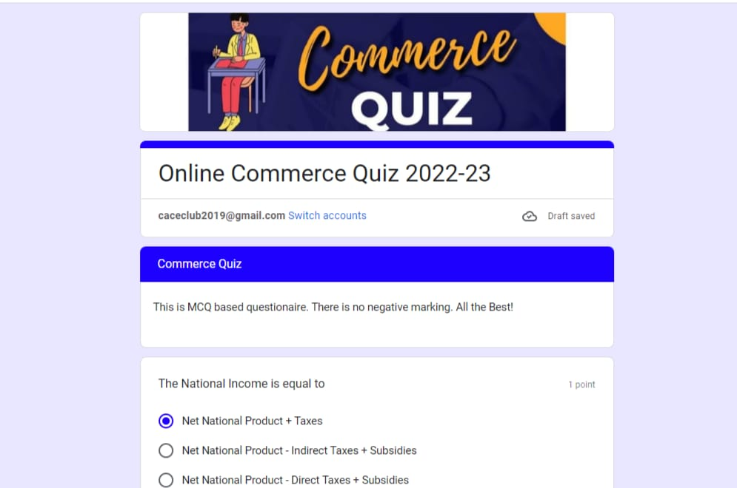

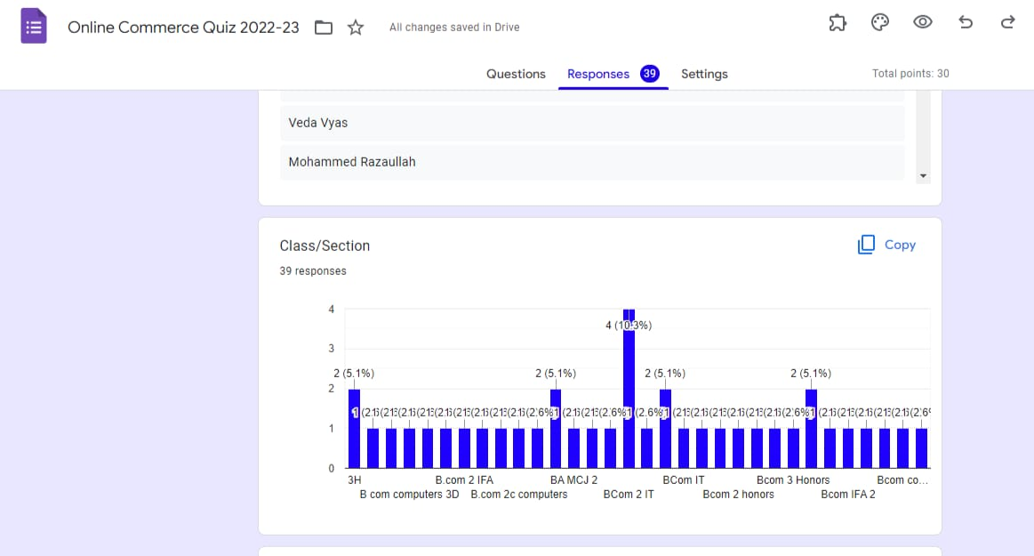

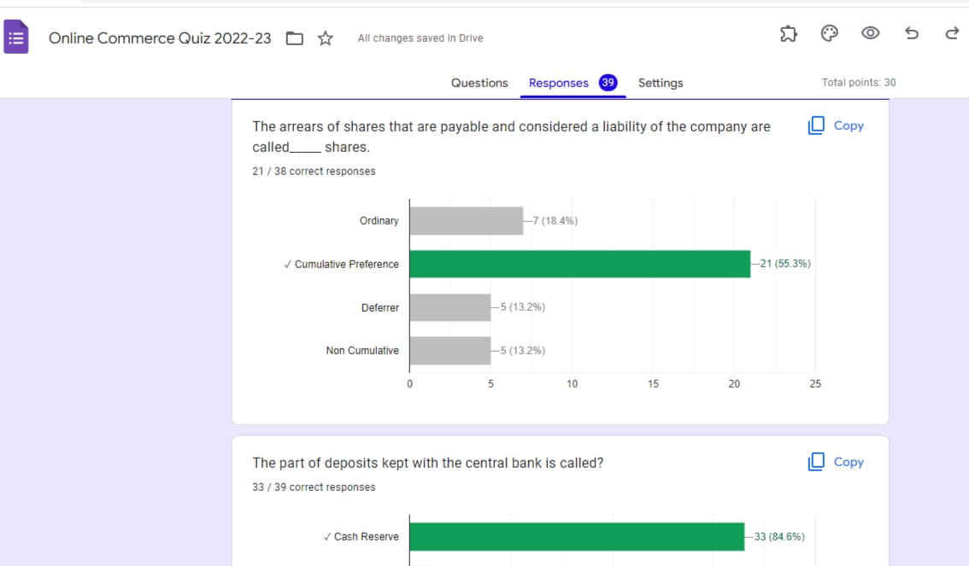

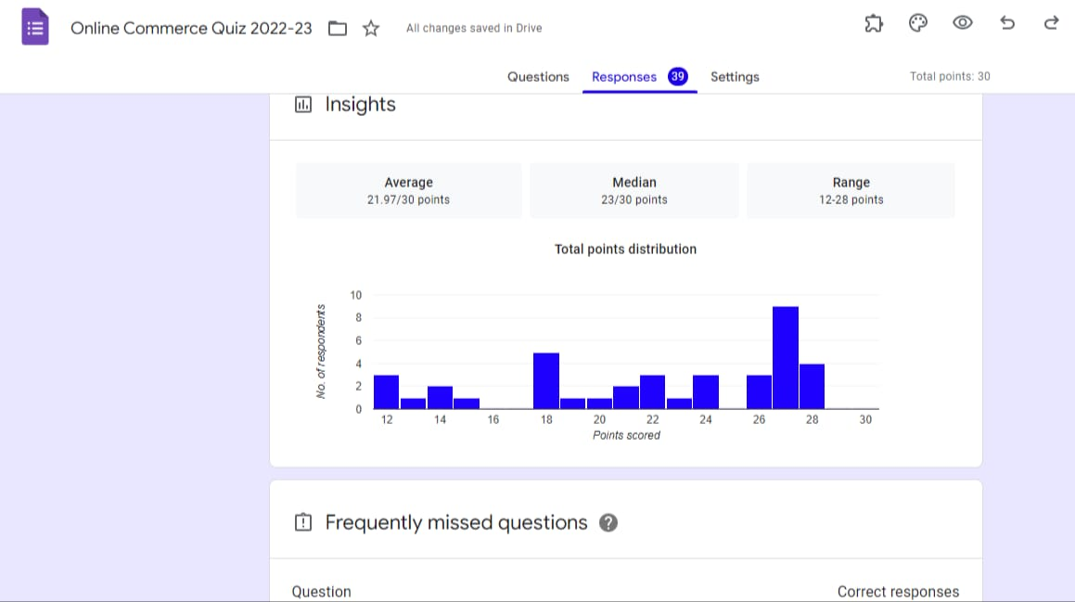

LINKS FOR REGISTRATION, CERTIFICATES AND FEEDBACK:
REGISTARATION LINK:
https://forms.gle/r6ATbN2iQ7KfEUdr9
FEEDBACK LINK:
https://forms.gle/1TKeRYFbxAVU1KALA
CERTIFICATE LINK:
https://forms.gle/1TKeRYFbxAVU1KALA

