ST. JOSEPH’S DEGREE & PG COLLEGE
(Autonomous), Affiliated to Osmania University
Re-accredited by NAAC (3rd Cycle) with B⁺⁺
King Koti Road, Hyderabad
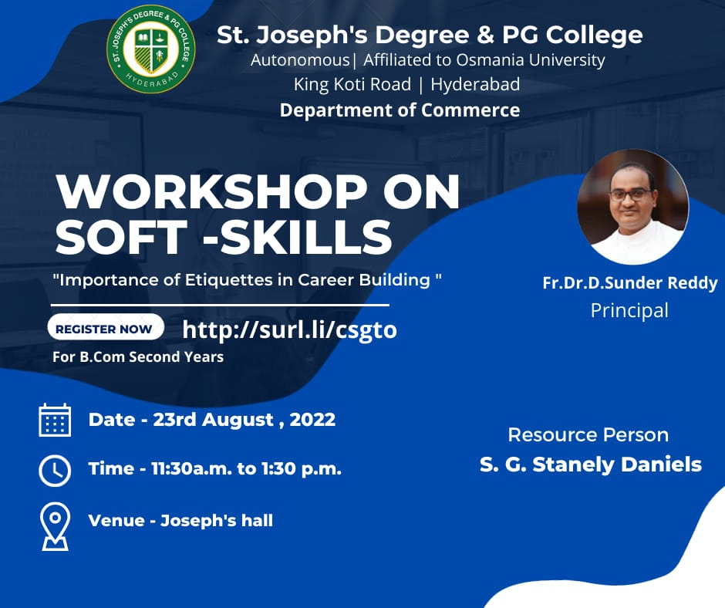

NAME OF THE EVENT: WORKSHOP ON SOFT-SKILLS
OBJECTIVE OF THE EVENT: Soft skills provide students with a strong conceptual and practical framework to build, develop and manage teams. They play an important role in the development of the students’ overall personality, thereby enhancing their career prospects. The soft skills training provides strong practical orientation to the students and helps them in building and improving their skills in communication, the effective use of English, business correspondence, presentations, team building, leadership, time management, group discussions, interviews, and inter-personal skills.
DATE TIME AND VENUE: 23rd August, 2022. Joseph Hall
Target group: B.Com II Year All Programs
Resource person: Stanly Daniels
Faculty Co-ordinators: T Krishna, S Bhanu Prakash Sarma

BRIEF REPORT: On Monday 23rd August 2022, the department of Commerce organized training program on “Corporate Grooming & Etiquette” for the benefit of second year students of St Josephs Degree and PG College. Mr. StanlyDaniels is the resource persons for this training program
The training Session began with Employability skills. In the training program, the students were taught about some good etiquette to be followed while attending interviews. Tips and guidelines for attending HR interview were also dealt in detail. Few frequently asked questions and the effective answers for those questions were discussed.

OUTCOME: The soft skills training provides strong practical orientation to the students and helps them in building and improving their skills in communication, the effective use of English, business correspondence, presentations, team building, leadership, time management.

Stanly Daniels

Ph # 0-8074701759
Hyderabad E-Mail ID: stanlydaniels@gmail.com

Date of Birth: 19th July
------------------------------------------------------------------------------------------------------------------------------------------
A Professional with more than 18 years of organizational experience, encompassing BPO operations (Media & Broadband), Customer Service, Training & Project Supervision.
Competent, decisive & dedicated professional poised to deliver responsible growth & results. Rich mix of Operations in media (DTH platform) & Broadband (AOL {US}), Training & Development & Project Supervision. Strategic thinking, efficient planning of project and successful implementation at all phases. A change agent, acknowledged for balanced judgment.

Professional Strengths:
- People Management
- Change Management
- Project Supervision
- Management Reporting

Career Chronology:
Training
Freelancing as a Soft skills/Employability Skills/Language/IELTS/GRE/PTE & Personality Development trainer for Reputed Colleges, Universities, Educational Institutes and Corporates from July 2009 till date. Run end-to-end project operations and maintain project reports.
- Conduct training workshops on Employability skills for students.
- Develop content & deliver training on soft skills.
- Instrumental in initiating & negotiating training programs for
different Universities.
- Actively developed content for workshops for different Universities PAN India.
- Delivered the above-said content to all affiliated colleges (308) of JNTUK, JNTUA, JNTUH, etc.
- Delivered CRT programs and Company specific trainings for Engineering and Management colleges Pan India.
- Managed end-to-end operations for training projects for various colleges and institutions.
- Initiated discussions with administration.
- Planned and executed training projects in various colleges.
- Tracking the quality and delivery techniques of trainers.
- Conducted Sales, Services & CSR trainings on behalf of a third-party vendor for companies like Hyundai and Nissan.

America OnLine.

Worked as a Sr.Customer Care Representative with AOL in customer service process for US from July 2007 till July 2009.
Job Responsibilities:

- Handling escalated calls from US customers and solving their issue
- Handle a team of 10 agents & monitor their performance.
- Ensure that the daily targets for individual agent & team targets are achieved.
- Coach, monitor & give feedback to agents on their Key SLA's.
- Manage documentation, internal client satisfaction and feedback process
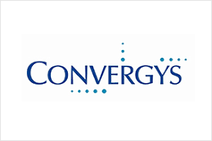
Convergys India Services.
Worked as a Customer Service Representative from March 2005 till June 2007 for US financial process.
Job Responsibilities:
- Answering calls from US citizens and checking if they are eligible to get loans.
- Identify potential candidates and process their applications and profiles to the respective bank.
- Training new hires once they hit the operation floor.
- Preparing Daily and Monthly reports.

ICICI Bank phone banking group:
Worked with ICICI bank Ltd as a Customer Service Officer from August 2004 to March 2005 in the inbound sales department.
Job responsibilities:
- Answering queries from customers & converting them to leads
- Identify & recommend suitable Asset & liability products to the customers
- Involved in training new hires on the products.
- Involved in preparing monthly reports for the Team Leads.

Education:
- Completed my Graduation.

Languages Known: English, Hindi and Telugu.

(Stanly Daniels)

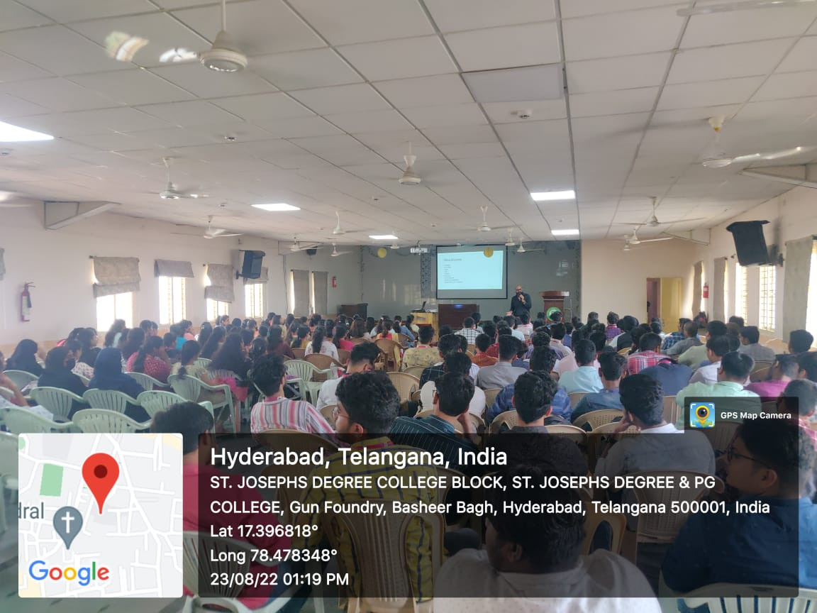

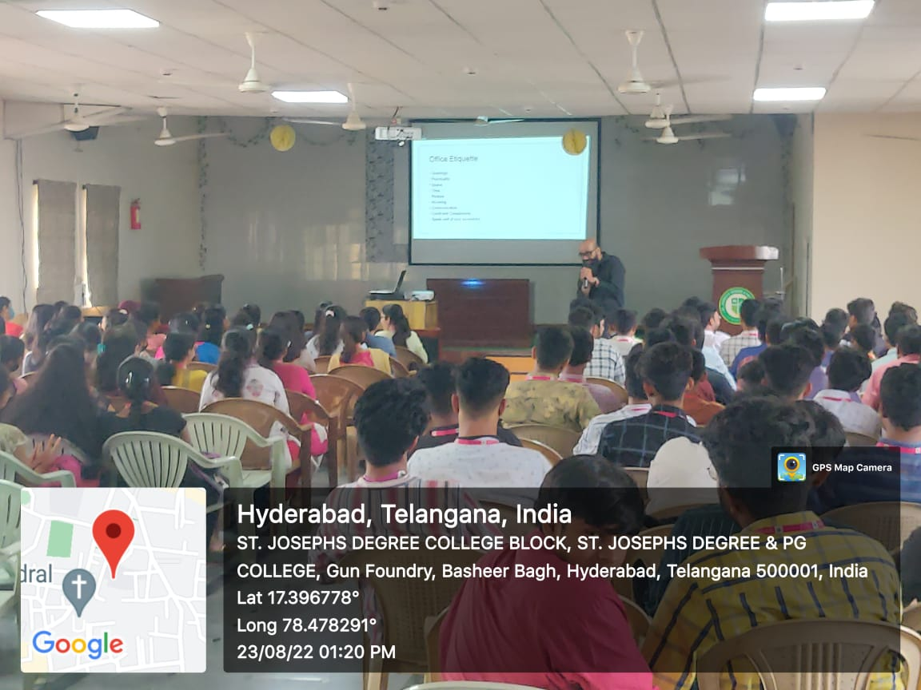

Student’s Feedback
At the end of the program, students were requested to provide their feedback about the Training Program. The form has 4 main sections: usefulness of the topics, top-3 achievements of the student, top-3 suggestions from the student.

